VIRGINIA’S WHAT-IFs

What Ifs…
A complete guide for helping voters with exceptional situations
Identification
Revised 07/2026

Situations 1-3

Address Changes

Situations 4-8

Extension of Polling Hours

Situation 9

Pollbook

Situations 10-14

Absentee

Situations 15-16

Assisting Voters

Situations 14-17

Voting Malfunctions
Situation 21-22

Moving Chart
Appendix A

Provisional Voting
Appendix B

Table of Contents

Abbreviations 4
Identification (ID)
- Voter does not have acceptable ID or you are unsure if you can accept the provided ID 5
- Name on ID does not match name in pollbook 6
- Voter provides address (orally or in writing) that does not match address in pollbook 7

Address Changes
- There is a ? next to voter’s name or pollbook says “Inactive” OR “Marked
for confirmation” 8
- Voter moved within the same precinct ..9
- Voter moved to a different precinct within the same county/city AND congressional district 10
- Voter moved to a different county/city OR different congressional district within the same county/city 11
- Voter moved to another state 12

Extension of Polling Hours
- Court orders polls to stay open past 7 p.m. 13

Pollbook
- Voter marked with the federal symbol F in pollbook 14
- Voter’s name is not in pollbook 15
- Voter’s name marked in pollbook as already voted 16
- Voter changes mind about voting 17
- There is an A symbol in the pollbook on the voter’s record……………………………..18

Absentee
- Absentee voter comes to polling place WITH their absentee ballot 19
- Absentee voter comes to polling place WITHOUT their absentee ballot 20,21

Assisting Voters
- Voter asks for help voting 22
- Voter asks election officer to translate the ballot 23
- Voter is blind or low vision and asks for assistance 24
- Voter asks to vote outside of the polling place 25

Voting Malfunctions
- You run low on official ballots or provisional ballot envelopes 26
  - If you run low on official ballot supplies 26
  - If you run low on provisional ballot envelopes 26
- Voting Equipment has malfunctioned
  - Electronic Pollbooks 27
  - Tabulation Machine-Scanner 27

Appendix A
“Moving Conditions” Chart 27

Appendix B
Provisional Reason Codes Chart 29
Voter must vote a provisional ballot 29
  - Same Day Registration Process Overview 30
  - Same Day Registration Process Reason Code #1……………………………………….31,32
  - Non-SDR Provisional Process Voter Reason Codes #3-7. 32

Abbreviations
AB Absentee Ballot
AB Report List of voters who have absentee voted or applied for an absentee ballot CAP Central Absentee Precinct
EPB Electronic Pollbook

GR General Registrar
ID Identification
OP Outside Polls
S Voter has completed a required statement including the Affirmation of Eligibility and Virginia Registration Application.
SDR Same Day Registration
SOR Statement of Results
VRA Voter Registration Application
24.2 Title of the Code of Virginia, also known as the Virginia Election Laws.
? Voter may have moved and must confirm their current residential address. Voter may also be listed as “inactive” or “marked for address confirmation.”
F Federal Only – overseas voter eligible to vote for federal offices only.
A Voter has yet to provide their social security number and it is required.

s The answer to this question determines which way to proceed.
- Indicates additional information.

1

Voter does not have acceptable ID or you are unsure you can accept the provided ID.
If the voter does not have an acceptable form of ID, the voter may sign an ID Confirmation Statement. Officer places completed documents in Envelope #8.
If the voter does not have an acceptable form of ID and does not complete or sign the statement, the voter can vote a provisional ballot. Go to Appendix B.
  - For federal elections, first see Help America Vote Act section below.
- Never turn a voter away because of lack of ID. If you are unsure whether a voter has presented an acceptable ID, call the GR.
- The GR may have provided a list of acceptable ID in the polling place. Ask the Chief Officer of Election if the list is available in the polling place. Otherwise, for a list of acceptable ID, go to elections.virginia.gov/voterid.

Help America Vote Act
If the voter is required by the Help America Vote Act (52 U.S.C. §21083(b)) to show identification the first time they vote in a federal election, the voter must present one of the following:
  - A current and valid photo identification.
  - A copy of a current utility bill, bank statement, government paycheck, paycheck, or other government document containing the name and address of the voter.
- If the voter does not have an acceptable form of ID, go to Appendix B and have them vote a provisional ballot. An ID Confirmation Statement is not acceptable in these circumstances.

2

Name on ID does not match name in pollbook.
- Allow voter to vote if the name on the voter’s ID is:
  - similar to the name in the pollbook; and/or
  - lists a maiden name, nickname, or initials instead of the full name.
- Ask voter to complete and sign a Voter Registration Application.
- Officer places completed documents in Envelope #8.

3

Voter provides address (orally or in writing) that does not match address in pollbook.
Does the address the voter provides orally or in writing match the address in pollbook?
  - If yes, check the voter in normally.
  - If no, go to situations 4-8.
- The address the voter provides orally or in writing must match the address in the pollbook but it does NOT have to match the address on the ID.
- If an address on an ID does not match the address on the pollbook, it does not make the ID unacceptable for proving voter identity.
- Some acceptable forms of ID do not have an address.
- If you are uncertain, call the GR.

4

There is a ? next to voter’s name or pollbook says

“Inactive” or “Marked for address confirmation.”
Has the voter moved?
  - If yes, go to situations 5-8
  - If no, the voter must complete the Affirmation of Eligibility Form.
    - Officer fills out and initials Section A on the Affirmation of Eligibility form.
    - Voter fills out and signs Section B –Affirmation of Voter.
    - Officer makes sure voter signs Section B.
    - Officer checks voter into the pollbook and indicates in the pollbook that a statement was signed. Depending on how your pollbooks are set up, you might need to enter the Chief’s password.
    - Officer places completed documents in Envelope #8.
    - Voter casts ballot as normal in precinct.
- Why does this happen?
Voter was sent an address confirmation notice and the Elections Office did not receive a response. The confirmation notice was sent because:
  - There was a possible address change OR
  - Previous mailings from the Election Office were returned as undeliverable.

5

Voter moved within the same precinct.

- Officer asks voter to complete and sign a Voter Registration Application to update their registration to their new address.
- Officer checks voter into the pollbook as normal.
- Officer places completed documents in Envelope #8.
- Voter casts ballot as normal in the precinct.
- Do not enter the voter’s new address in the pollbook.

Town Elections Only
A voter who moved out of town cannot vote in the town election but may be eligible to vote in non-town elections §24.2-101; Qualified voter in a town. Ballots should be available to use that have no town offices on them in case of this scenario.

6

Voter moved to a different precinct within the same county/city AND congressional district.

Choose which statement describes when the voter moved and use the instructions that follow. Review Appendix A for a detailed moving chart.

sVoter moved on or after November 5, 2025
- Voter completes and signs a Voter Registration Application.
- Officer checks voter into the pollbook as normal.
- Voter casts ballot as normal in precinct where still registered.
- Officer places completed documents in Envelope #8.

sVoter moved from November 9, 2022 through November 4, 2025.
- Officer fills out and initials Section A on the Affirmation of Eligibility form.
- Voter fills out and signs Section B – Affirmation of Voter using their new address.
- Officer checks voter into the pollbook and indicates in the pollbook that a statement or oath was signed.
- Voter casts ballot as normal in precinct where still registered.
- Officer places completed documents in Envelope #8.

sVoter moved on or before November 8, 2022.
- Voter may vote a provisional ballot using the SDR process. Do not enter voter’s new address in pollbook.
- If voter arrives in new precinct, must vote provisionally via SDR unless the voter qualifies to vote a regular ballot in former precinct in above scenarios and is willing/able to travel to that precinct. Go to Appendix B for Same Day Registration.

Town Elections Only
A voter who moved out of town cannot vote in the town election but may be eligible
to vote in non-town elections. §24.2-101; Qualified voter in a town. Ballots should be available to use that have no town offices on them in case of this scenario.

7

Voter moved to a different county/city OR a different congressional district within Virginia.

- Some counties/cities have more than one congressional district. If you do not have a street file map, call the GR.
Choose which statement describes when the voter moved and use the instructions that follow. Review Appendix A for a detailed moving chart.

sVoter moved on or after November 5, 2025
- Voter completes and signs a Voter Registration Application.
- Officer checks voter into the pollbook as normal.
- Voter casts ballot as normal in precinct where still registered.
- Officer places completed documents in Envelope #8.

sVoter moved from November 9, 2022 through November 4, 2025.
Voter may vote a provisional ballot. See Appendix B for SDR.
- Do not enter voter’s new address in pollbook.
- If voter moved to a new precinct within the same county/city AND congressional district go to Situation 6.

sVoter moved on or before November 8, 2022.
Voter may vote a provisional ballot. See Appendix B for SDR.
- Do not enter voter’s new address in pollbook.
- If voter moved to a new precinct within the same county/city AND congressional district go to Situation 6.

Town Elections Only
A voter who moved out of town cannot vote in the town election but may be eligible to vote in non-town elections. §24.2-101; Qualified voter in a town. Ballots should be available to use that have no town offices on them in case of this scenario.

8

Voter moved to another state.

Is this a presidential election?

sIf No, go to Situation 8a.
sIf Yes
- Did the voter move out of state more than 30 days ago? Go to Situation 8a.
- Did the voter move out of state less than 30 days ago? Go to Situation 8b.

8a:
Voter is no longer eligible to vote in Virginia.
- Ask voter to fill out a Cancellation Request form (ELECT 427(A)) or write and sign a note that:
  - states they have moved out of state;
  - asks to cancel their Virginia voter registration; and
  - includes their name, date of birth, and new address, (SSN optional).
- Place Cancellation Request or note in Envelope #8.
If voter insists they are registered and eligible to vote in the precinct, they may vote a provisional ballot. See non-SDR provisional instructions on page 32 in Appendix B.

8b:
Voter may vote a “Presidential-Only” Ballot.
(This is a presidential election AND voter moved out of state less than 30 days ago.)
- Officer fills out and initials Section A on the Affirmation of Eligibility form.
- Voter fills out and signs Section B – Affirmation of Voter using new address.
- Officer tells voter that the GR will cancel the voter’s Virginia registration after this election.
- Officer checks voter into the pollbook and indicates in the pollbook that a statement was signed.
- Officer indicates in the pollbook that voter voted a presidential-only ballot.
- Officer issues a presidential-only ballot.
- Voter casts presidential-only ballot as normal in the precinct.
- Officer places completed documents in Envelope #8.

9

Court orders polls to stay open past 7 p.m.

Voters who arrive at the polling place after 7 p.m. will vote a provisional ballot.
  - Let all voters who arrive BEFORE 7 p.m. finish voting before you begin issuing provisional ballots to those who arrive after 7 p.m.
- Locate a new Provisional Ballot Log for each check-in line.
- Check voters into pollbook as provisional.
  - On paper pollbooks, do not write anything in the paper pollbook.
- Record each voter’s information onto Provisional Ballot Log using Reason #3.
- Go to Appendix B and follow instructions for issuing a provisional ballot using Reason #3.
  - Voter does not have to fill out Voter Registration Application, unless needed for another reason.
  - All provisional ballots issued using Reason #3 (and their log pages) must be separated from other provisional ballots and placed in Envelope #1

10

Voter marked with federal symbol F in pollbook.
  - Symbol may be in the voter’s details, message box, or ballot style.
  - Voter may only vote a regular ballot for federal offices but may vote full provisional ballot via Same Day Registration (SDR), if qualified.
Inform the voter of their eligibility to vote a regular ballot for only federal races and that they may vote a full ballot provisionally using the SDR process, if they are qualified to register and vote in that precinct.

sIf voter elects to use SDR:
- Go to Appendix B to complete the SDR process.

sIf voter does not qualify or otherwise elect to use SDR:
- Find the Federal-Only Ballot Record Report and follow instructions.
- Check voter into the pollbook.
- Check ‘Federal Only’ flag.
- Give voter a Federal Only ballot.

10a

Voter marked with federal F and absentee symbols AB in pollbook and they have their absentee ballot.
Go to Situation 15 and follow instructions.

10b

Voter marked with federal F and absentee symbols AB in pollbook and they DO NOT have their absentee ballot.
Go to Situation 16 and follow instructions.

11

Voter’s name is not in the pollbook.
  - Make sure to look:
    - in the pollbook;
    - at the end of the alphabetical section in the paper pollbook; and
    - in any other listings provided by the GR.
- Check for correct spelling or a recent name change.
- Check if voter is in the right polling place. Ask voter for their:
  - address;
  - when/where they registered to vote; and
  - when/where they last voted.
- Collect any documentation or registration receipts provided by the voter and put them in Envelope #8.
- If the voter is a Same-Day Registration (SDR) voter, see Appendix B.
- Call the GR. The GR will either:
  - instruct you to add a voter’s name to the pollbook;
  - tell you the person can vote a provisional ballot. (See Appendix B); or
  - let you know if voter is registered and eligible to vote in another precinct.
  - If GR is unavailable or unable to confirm qualifications, voter may vote a provisional ballot.
See Appendix B.
  - Overseas and Military voters (or voters who have recently separated from the military) as well as spouses and dependents may be able to register today,
§ 24.2-420.1. Call the GR.
  - Only the GR can authorize adding a voter to the pollbook. The GR will give you instructions if that is necessary.

12

Voter’s name marked in pollbook as already voted.
- Tell voter they can vote a provisional ballot.
- Go to Appendix B and follow instructions using Reason Code #5.
  - Voter does not have to fill out a Voter Registration Application, unless needed for another reason.

13 Voter changes mind about voting.

- It is the right of every voter to change his/her/their mind in voting in an election. The voter must come back to the officers, express a mistake in voting, and surrender an unvoted ballot.

If the voter has NOT yet scanned their ballot, for electronic pollbooks (EPBs) use your EPB instructions to:
    - look up the voter;
    - undo check-in and
    - leave unchecked (if they don’t want to vote) or re-check the voter in for the correct primary

The pollbook officer will likely need the Chief Officer to enter the Chief’s password to complete the check-in process.
  - If voter has already been issued a ballot, you will first need to spoil the ballot and place it in the spoiled ballot envelope.
  - After the polls close, the number of names stricken from a primary election’s pollbook because the voter changed their mind or was given the wrong ballot must be entered on that Primary’s Statement of Results for in the EXPLANATION OF DISCREPANCY section.
For paper pollbooks, follow the separate instructions from ELECT.

14

There is an A symbol in the pollbook on the voter’s record.

  - On the EPB, the A symbol may be in the voter’s details or in the message box.

  - On paper pollbooks, the A symbol appears left of the voter’s name.

  - This is very rare.

- Voter fills out a Voter Registration Application.
- Officer writes ‘SSN update’ next to or above the social security number on the form.
- Do not enter the social security number in the pollbook.
- Do not ask voter to say their social security number aloud.
  - What does this mean?
The Election Office does not have this voter’s social security number and it is required.

15 Absentee voter comes to polling place

WITH their absentee ballot. If voter does not have their absentee ballot, go to 16.

- Officer makes sure that voter’s name in the pollbook OR Final Absentee List shows status as “Issued” or “Unmarked.” If not, call GR’s office.
- Officer notes on the absentee voter applicant list, opposite the name of the person returning the ballot, the fact that the ballot was returned unused and the date of the return.
- Voter removes ballot from envelope and writes ‘SPOILED’ on the front of the ballot. If voter filled in any part of the ballot, they can fill in the rest of the ovals for privacy of their original vote.
- Voter returns the ballot and any other related materials to the envelope or attaches them together.
- Officer places the spoiled ballot pkg. in Envelope #4.
- Officer checks voter into pollbook and has them cast vote as normal.
  - Checking in this voter may require the Chief’s password to override the AB symbol and complete the check-in process.
- Ballot officer indicates on the Ballot Record Report that an absentee ballot has been returned and spoiled.
- On paper pollbooks, draw line through ‘AB’ next to voter’s name and assign the next pollbook count number.
- Voters marked with a federal symbol in pollbook may vote a ballot for federal offices only. A ballot issued to this voter must be a federal-only ballot. However, the voter may vote a full provisional ballot using Same Day Registration if qualified to register and vote in that precinct. Go to Appendix B for Same Day Registration.

16 Absentee voter comes to polling place WITHOUT their absentee ballot.

16a On Election Day: Voter’s name in the pollbook OR Final Absentee List shows status as “Issued” or “Unmarked.” If not, go to 16c.
Call the Election Office to ask if voter returned an unmarked ballot.
- If GR tells you that voter returned an unmarked ballot, have voter cast vote as normal.
- If GR tells you that voter did not return their ballot or you cannot reach the Election Office, have voter vote a provisional ballot. Go to Appendix B using Reason #4.

16b Before Election Day: Voter’s name in the pollbook OR Final Absentee List shows “Issued” or “Unmarked status.” If not, go to 16c.
Call the Election Office to ask if voter returned an unmarked ballot.
- If GR tells you that voter returned an unmarked ballot, have voter cast vote as normal.
- If voter lost or did not receive their ballot, and GR tells you that voter did not return their ballot (or you cannot reach the Election Office), voter may complete a “Statement of Voter to be Used when Absentee Ballot Not Received or Lost” (goldenrod) form. If voter signs and completes this form, they can vote a replacement ballot.
- If the voter does not wish to sign the form, have the voter vote a provisional ballot. Go to Appendix B using Reason #4
  - Voters marked with a federal symbol in pollbook may vote a ballot for federal offices only. A ballot issued to this voter must be a federal-only ballot. However, the voter may vote a full provisional ballot using Same Day Registration if qualified to register and vote in that precinct. Go to Appendix B for Same Day Registration
  - Non-Same Day Registration voters do not have to fill out Voter Registration Application, unless needed for another reason.

16c -Voter’s name in the pollbook OR Final Absentee List shows status as “Marked” or “On Machine.”
- If voter’s record says ‘marked’ or ‘on machine’ (instead of “issued”) voter has already voted and cannot vote again.
- If voter says they did not vote, go to Appendix B using Reason #5.

17 Voter asks for help voting.

- Officer explains the purpose of the Request for Assistance form to the voter and assistant.
- Officer helps the voter determine who the assistant will be. Use the criteria on the Request for Assistance form.
- Voter signs Section A – Request of Voter.
  - If voter is unable to sign, ask the assistant to write ‘voter unable to sign’ and to print the voter’s name.

- Assistant fills out and signs Section B – Agreement of Assistant.
- Officer checks in voter as normal.
- Officer indicates in the pollbook that assistance was given.
- Officer shows the voter and assistant to the voting booth.
- Voter or assistant places the ballot in the scanner or ballot box.
- Officer places completed documents in Envelope #8.
  - If appropriate, let voters know they have the option to mark their ballot using an electronic ballot marking device with an audio ballot and/or larger text.
  - If the assistant chosen by the voter is age 15 or younger, neither the voter nor the assistant is required to complete the form.

18 Voter asks an Election Officer to translate the ballot.
Who is allowed to translate a ballot and instructions for a voter?
    - An Election Officer. Follow the instructions below.
    - A volunteer including third party volunteers. See Situation17.
    - A person designated by the voter. See Situation17.
  - One representative interpreter for each party or candidate is allowed to observe.
- Officer explains the purpose of the Request for Assistance form to the voter and assistant.
- Voter fills out and signs Section A – Request of Voter.
- Election Officer-Translator fills out and signs Section C – Voter Asks Officer to Translate Ballot.
- If Election Officer-Translator will be assisting the voter in the booth, they must also complete and sign Section B – Agreement of Assistant.
- Officer checks voter in as normal and indicates they used an assistance form.
- Officer shows voter to the voting booth (and assistant, if requested).
- Voter or assistant places the ballot in the scanner or ballot box.

- If the assistant chosen by the voter is age 15 or younger, neither the voter nor the assistant is required to complete the form.

19 Voter is blind or low vision and asks for assistance.
  - Let voters know they have the option to mark their ballot independently using an electronic ballot marking device with an audio ballot and/or larger text.
  - If the voter chooses to use the electronic ballot marking device, an assistant may help but is not required. If the voter uses an assistant:
- Officer explains the purpose of the Request for Assistance form to the voter and assistant.
- Officer helps the voter determine who the assistant will be. Use the criteria for blind voters on the Request for Assistance form.
  - Voters who are blind do not have to sign this form, but they must show ID.
- Officer writes ‘blind voter’ on the signature line in Section A – Request of Voter and prints voter’s name on the line below the signature.
- Assistant completes and signs Section B – Agreement of Assistant.
- Officer checks in the voter as normal.
- Officer indicates in the pollbook that assistance was given.
- Officer shows the voter and assistant to the voting booth.
- Voter or assistant places the ballot in the scanner or ballot box.
- Officer places completed documents in Envelope #8.

- If the Election Officer is explaining how the electronic ballot marking device works, but will not be assisting voter with the ballot itself, no Request for Assistance form is needed.

20 Voter asks to vote outside of the polling place.
Voters may vote outside and within 150 feet of the entrance to the polling place if they:
- Are 65 or older; OR
- Have a disability (mentally or physically).

- Check voter into the pollbook as normal (including a review of ID).
- Indicate in the pollbook that this is an Outside the Polls (OP) voter.
- Two Election Officers from different political parties bring the Request for Assistance form, pen, privacy envelope, and ballot to the voter.
- Officer will place the voted ballot in the scanner or ballot box.

  - If this would leave too few Election Officers in the polling place to meet legal requirements, then the Election Chief or Assistant Election Chief can go alone.
  - If voter asks for help voting, go to Situation17.
  - The voter does not need to provide proof of a disability, such as a doctor’s note, to be eligible for curbside voting.

21 You run low on official ballots or provisional ballot envelopes.

21a
If you run low on official ballot supplies:
- Chief Officer will ask the Electoral Board for more ballots.
- If directed by the local Electoral Board, follow instructions on the “Authorization to Reproduce Ballots” form to reproduce ballots.

21b

If you run low on provisional ballot envelopes, create an envelope on plain paper:
- Use Appendix B for provisional ballot instructions.
- Copy the relevant side (SDR or Non-SDR) of an unused provisional envelope onto a single piece of paper. This paper does not need to be green.
- Fill out fields as you would on the normal provisional ballot envelope.
- Wrap and secure the paper with the provisional ballot-envelope information around the voter’s completed provisional ballot.
  - Use available materials, such as paper clips.

22 Voting equipment has malfunctioned.

22a

Electronic Pollbooks
- Contact the GR and follow their instructions.
- Use provided paper copies of pollbooks.

22b

Tabulation Machine - Scanner
- Contact the GR and follow their instructions.
- Continue normal check-in procedures allowing voters to vote.
- Place the uncounted ballots in a secure container or compartment.
- Count the ballots after the polls close.
  - If you have a working scanner, run each of the uncounted ballots through the scanner.
  - If you do not have a working scanner, count the ballots manually.

Appendix A: “Moving Conditions” Chart

If the voter is already in the Pollbook, ask the voter:
Question #1: Where did you move?
Question #2: When did you move?
How far did voter move?  è  When did voter move?  ê | Within  precinct  See What-If #5 for more details | Within county/city AND congressional district (but not the same precinct).  See What-If # 6 for more details | To a different county/city OR congressional district (still within Virginia)  See What-If # 7 for more details | Outside of Virginia  See What-If # 8a/8b for more details
On or After November 5,  2025 | Voter can vote a regular ballot (Ask voter to complete regular Voter Registration Application to update registration) | Voter can vote in precinct where registered.  -OR-  Voter may vote provisional using SDR in precinct where they now live. | Voter can vote in precinct where registered.  -OR-  Voter may vote provisional using SDR in precinct where they now live. | Voter no longer eligible to vote in Virginia  (see 8b for possible exception for presidential elections)
From November 9,  2022 through  November 4,  2025 | Voter can vote a regular ballot (Ask voter to complete regular Voter Registration Application to update registration) | Voter can vote in precinct where registered after signing Affirmation of Eligibility.  -OR-  Voter may vote provisional using SDR in precinct where they now live. | Voter may vote using SDR in precinct where they now live. | Voter no longer eligible to vote in Virginia  (see 8b for possible exception for presidential elections)
On or Before November 8,  2022 | Voter can vote routinely (Ask voter to complete regular Voter Registration Application to update registration) | Voter may vote using SDR in precinct where they now live. | Voter may vote using SDR in precinct where they now live. | Voter no longer eligible to vote in Virginia  (see 8b for possible exception for presidential elections)

Appendix B: Provisional Voting.

Same Day Registration (or not on pollbook) Pages 30,31,32
1 | Voter not on the pollbook and:  - is unregistered and otherwise qualified to register using Same Day Registration;  - is a resident of the precinct or has been since the November general election last year; or,  - has been a resident of the precinct for the last two federal elections, is now a resident of the county or city, and current residence is in the same congressional district as this precinct.
Non-Same Day Registration Page 31
3 | Voter is voting after hours due to court order.
4 | Voter applied for an absentee ballot, but does not have the ballot with them.
5 | Voter is shown in the pollbook as already having voted.
6 | Other (any reason not captured in the other codes).
7 | Voter did not show required ID and did not sign a statement swearing to their identity.

- Provisional ballots must be cast in the precinct where the voter is qualified to vote—this usually means the provisional ballot will be cast in the precinct where the voter currently lives.
- If there is a dual-party primary, there will be a separate Provisional Ballot Log for each primary.

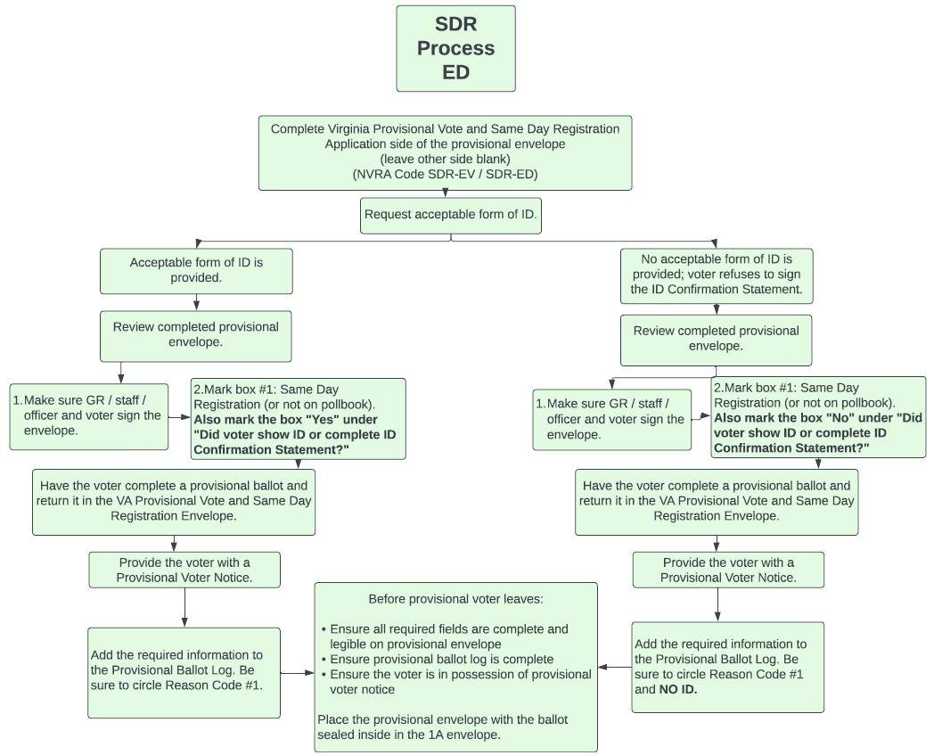
Same Day Registration Process Overview

Same Day Registration Process Reason Code #1.

- First Use the following chart to confirm eligibility for SDR:

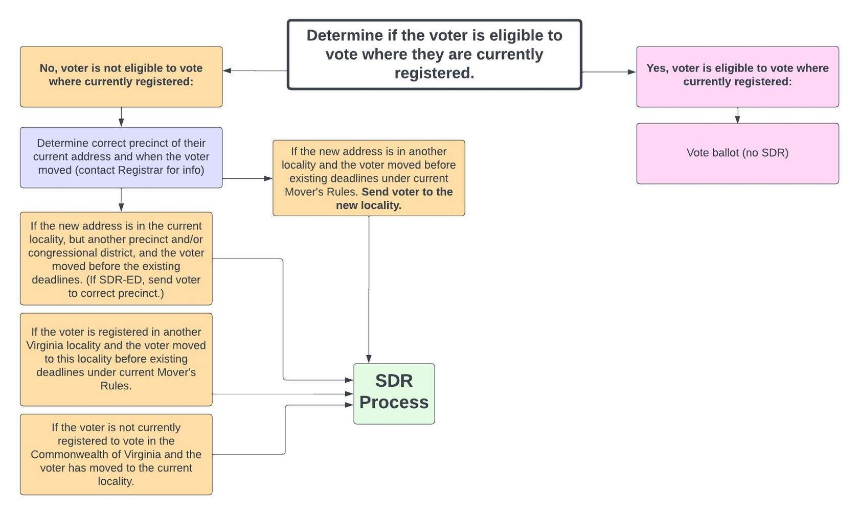

If the voter is eligible then follow the below written steps to complete the SDR process:

Complete only Same Day Registration (SDR) side of provisional envelope.
- Voter completes SDR side of envelope and signs the affirmation statement.
- Officer selects “Reason Code #1: Same Day Registration (or not on pollbook)” in ELECTION OFFICER box on the envelope.
- Officer asks voter for ID and selects “Yes” or “No” to question “Did voter show ID or complete ID Confirmation Statement?” in the ELECTION OFFICER box on the envelope.
- Officer signs envelope in ELECTION OFFICER box on envelope.
- Officer gets a ballot from the ballot officer.
- Ballot Officer marks on the Ballot Record Report that a provisional ballot was used.
- Voter votes a ballot and seals ballot in the provisional ballot envelope.

- Officer copies the information from the green provisional envelope onto Provisional Ballot Log.
- Officer places the envelope in provisional ballot box.
- Officer gives voter the green Provisional Voter Notice.
- Officer checks voter in as a provisional voter or otherwise indicates in the pollbook that voter voted a provisional ballot.

Non-SDR Provisional Process Voter Reason Codes #3-7.

Complete only Non-SDR side of provisional envelope.
- Voter completes non-SDR side of envelope and signs the Statement of Voter.
- Officer asks voter for ID. If ID is not provided (and ID Confirmation Statement is not completed), Officer selects “Reason Code #7: Voter does not have required ID and declined to complete ID Confirmation Statement” in ELECTION OFFICER box on envelope.
- Officer marks all other applicable Reason Codes #3-6 as reason for casting a provisional ballot in ELECTION OFFICER box on envelope.
- Officer signs envelope in ELECTION OFFICER box on envelope.
- Officer gets a ballot from the ballot officer.
- Ballot Officer marks on the Ballot Record Report that a provisional ballot was used.
- Voter votes a ballot and seals ballot in the provisional ballot envelope.
- Officer copies the information from the green provisional envelope onto Provisional Ballot Log. Officer places the envelope in provisional ballot box.
- Officer gives voter the green Provisional Voter Notice.
- Officer checks voter in as a provisional voter or otherwise indicates in the pollbook that voter voted a provisional ballot.

2026 Document Change Log
Section | Page | Change | Reason for Change
Whole Document |  | Language Changed from "Problem" to "Situation" | Per GR and staff feedback to ensure that the document is communicating that these are normal situations that occur rather than "problems"
Whole Document |  | Moved Revision Date to only being on front page | To limit the amount of updates needed for each update
Whole Document |  | Reordering of Situations | Changed per GR Feedback for a more logical order
Identification | 5 | Deleted full list of acceptable IDs | Changed per GR feedback as this is typically printed out separately anyways and ELECT’s page should be the central reference point.
Table of Contents | 1, 2 | Updated to match new order
Appendix A | 29 | Moving chart pulled out from the situations to an appendix. Updated with additional clarifying text and color | Changed because many GRs reported printing it separately; added color for ease of use.
Appendix B | 30 | Provisional Voting Process pulled out to separate appendix and reorganized with additional flow charts from the online SDR training and information for SDR | Changed to make it easier to find. More information and flow charts added due to GR feedback that there was not enough information on the steps and processes of SDR.
Town Elections Only | 9,10,11 | Added "Ballots should be available to use that have no town offices on them in case of this scenario.” | Added from suggestion to remind election staff to prepare for potential situation.
Accessibility | 23-26 | Retitled this section to "Assisting Voters" | Updated the title of this section due to GR feedback that OOEs often had trouble finding what they were looking for because they interpreted accessibility as the physical accessibility of the building and environment rather than the task of assisting voters with disabilities.
Whole Document |  | Removed any reference to challenging a voter | Effective July 1, 2026- Challenging a voter in a polling place is eliminated.

§24.2-643(C)
§§24.2-428.2, 24.2-651
§24.2-401
§24.2-401
§24.2-401
§§24.2-401, 24.2-402
§§24.2-420.1, 24.2-453,24.2-653.1, 24.2-708, 24.2-711, 24.2-712
Use Affirmation of Eligibility from ELECT-651
§24.2-651.1
Constitution of Virginia Art. II, Sec. 2; §§24.2-418, 24.2-643(D)
§§24.2-708, 24.2-709
§§24.2-653, 24.2-707, 24.2-708
Use Request for Assistance form ELECT-649, §24.2-649
Use Request for Assistance form ELECT-649, §24.2-649(C)
Use Request for Assistance form ELECT-649, §24.2-649
§§24.2-638, 24.2-649; 42. U.S.C §12102, 42 U.S.C. §12132
Use Authorization to Reproduce Ballots form ELECT-646.1, §24.2-646.1
§24.2-653

